Law Management Firm
Objective:
Law management system is an online application to store all the Lawyer Case Record information.
Users of the System:
- Admin
- Lawyers
- Pharmacists
- Clients
- Billing User
Functional Requirements:
- Clients should be able to check Lawyer availability and book the appointment.
- Lawyer should be able to accept or reject appointment.
- Lawyer Case Review Record should be viewable to all departments.
- Billing user to bill based on all the transactions done keep a record of the same.

While the above ones are the basic functional features expected, the below ones can be nice to have add-on features:
- Multi-factor authentication for the sign-in process
- Payment Gateway

Output/ Post Condition:
- Weekly based lawyer wise case report file
- Standalone application / Deployed in an app Container

Non-Functional Requirements:

Security | - App Platform –UserName/Password-Based Credentials  - Sensitive data has to be categorized and stored in a secure manner  - Secure connection for transmission of any data
Performance | - Peak Load Performance  - Law management System -< 3 Sec  - Admin application < 2 Sec  - Non Peak Load Performance  - Admin Application < 2 Sec
Availability | - 99.99 % Availability
Standard Features | - Scalability  - Maintainability  - Usability  - Availability  - Failover
Logging & Auditing | - The system should support logging(app/web/DB) & auditing at all levels
Monitoring | - Should be able to monitor via as-is enterprise monitoring tools
Cloud | - The Solution should be made Cloud-ready and should have a minimum impact when moving away to Cloud infrastructure
Browser Compatible | - IE 7+  - Mozilla Firefox Latest – 15  - Google Chrome Latest – 20  - Mobile Ready

Technology Stack
Front End | React 7+  Google Material Design  Bootstrap / Bulma
Server Side | Spring Boot  Spring Web (Rest Controller)  Spring Security  Spring AOP  Spring Hibernate
Core Platform | OpenJDK 11
Database | MySQL or H2

Platform Pre-requisites (Do’s and Don’ts):
- The React app should run in port 8081.
- Spring boot app should run in port 8080.

Key points to remember:
- The id (for frontend) and attributes(backend) mentioned in the SRS should not be modified at any cost. Failing to do may fail test cases.
- Remember to check the screenshots provided with the SRS. Strictly adhere to id mapping and attribute mapping. Failing to do may fail test cases.
- Strictly adhere to the proper project scaffolding (Folder structure), coding conventions, method definitions and return types.
- Adhere strictly to the endpoints given below.

Application assumptions:
- The login page should be the first page rendered when the application loads.
- Manual routing should be restricted by using AuthGaurd by implementing the canActivate interface. For example, if the user enters as http://localhost:4200/signup or http://localhost:4200/home the page should not navigate to the corresponding page instead it should redirect to the login page.
- Unless logged into the system, the user cannot navigate to any other pages.
- Logging out must again redirect to the login page.
- To navigate to the admin side, you can store a user type as admin in the database with a username and password as admin.
- Use admin/admin as the username and password to navigate to the admin dashboard.

Validations:
- Basic email validation should be performed.
- Basic mobile validation should be performed.
Project Tasks:
API Endpoints:
CLIENTS
Action | URL | Method | Response
Login | /login | POST | true/false
Signup | /signup | POST | true/false
Get All Lawyer | /Lawyer | GET | Array of Lawyers
Add Booking | /booking | POST | Booking Created
Remove Booking | /booking/{id} | DELETE | Booking Removed
Get Case Record | /Case Record/{id} | GET | Return the Case Record based on id
LAWYER
Action | URL | Method | Response
Get All Booking | /Lawyer/booking | GET | Array of Booking
Approve Booking | / Lawyer/booking | POST | Booking Appproved
Reject Booking | / Lawyer/booking/{id} | DELETE | Booking Deleted
Add Case Record | /Lawyer/Case Record | POST | Case Record Created
Update Case Record | /Lawyer/Case Record/{id} | PUT | Case Record Updated
Delete Case Record | /Lawyer/Case Record/{id} | DELETE | Case Record Deleted
ADMIN
Get All Lawyer | /Admin/Lawyer | GET | Array of Lawyer
Get Lawyer By Id | /Admin/Lawyer/{id} | GET | Return Lawyer details by Id
Add Lawyer | /Admin/Lawyer | POST | Lawyer Created
Update Lawyer | /Admin/Lawyer/{id} | PUT | Lawyer Updated
Delete Lawyer | /Admin/Lawyer/{id} | DELETE | Lawyer Deleted

Frontend:
Client:
Login:
Output Screenshot:
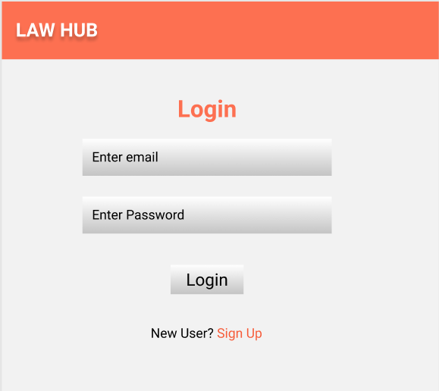

Signup:
Output Screenshot:
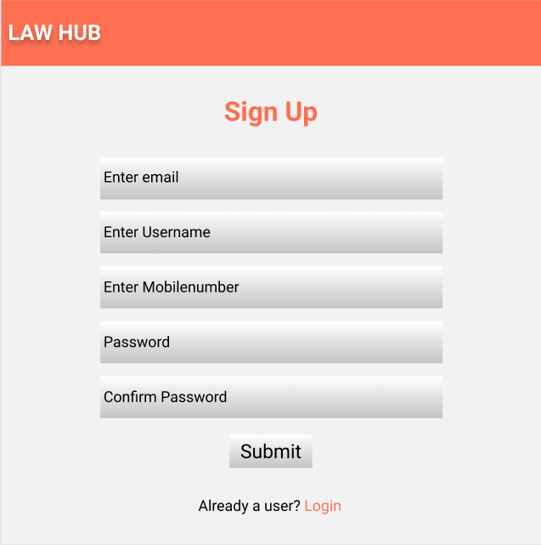
Home:
Output Screenshot:
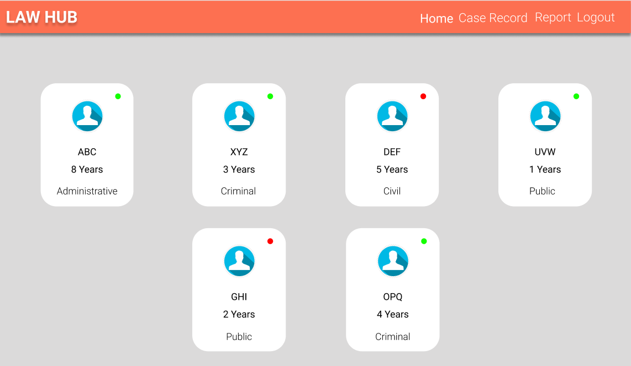

Appointment:
Output Screenshot:
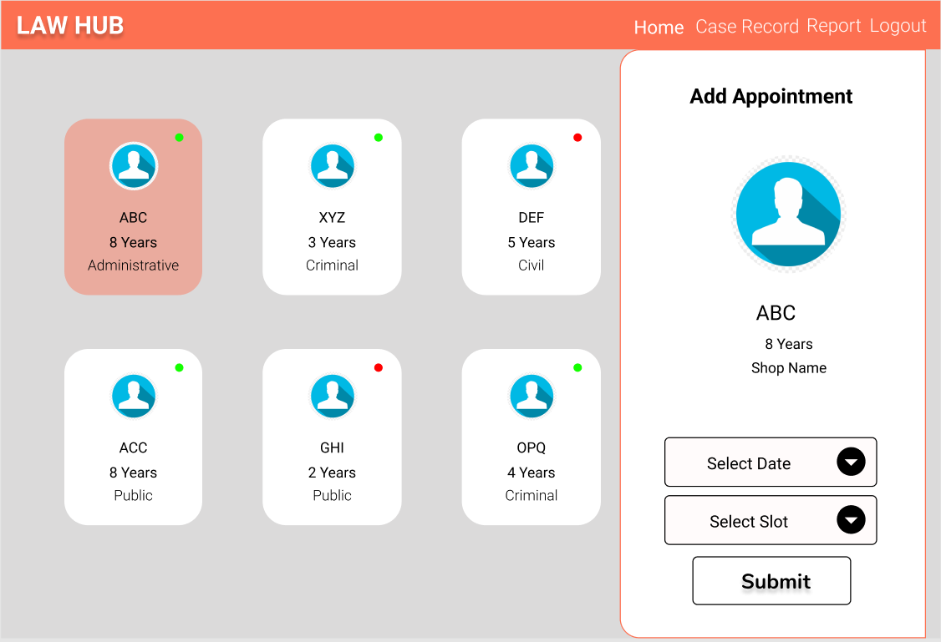
Case Record:
Output Screenshot:
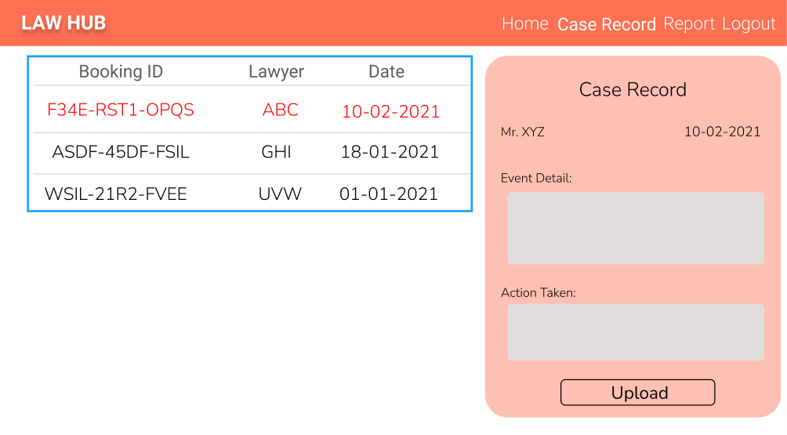

Report:
Output Screenshot:
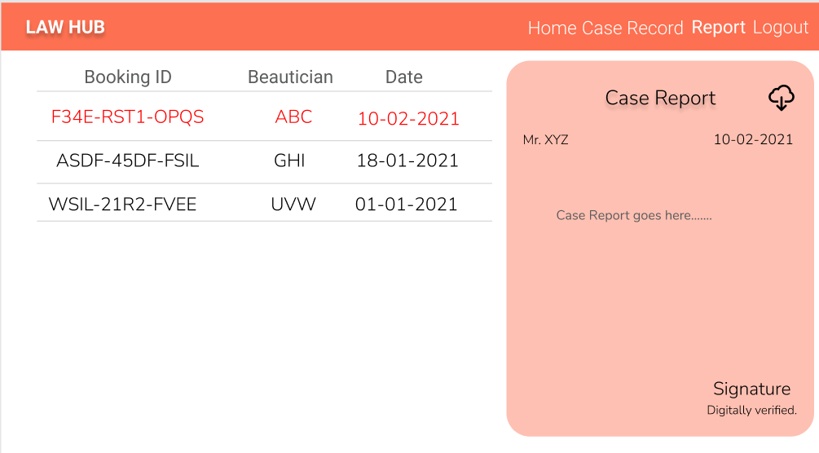

Lawyer:
Home:
Output Screenshot:
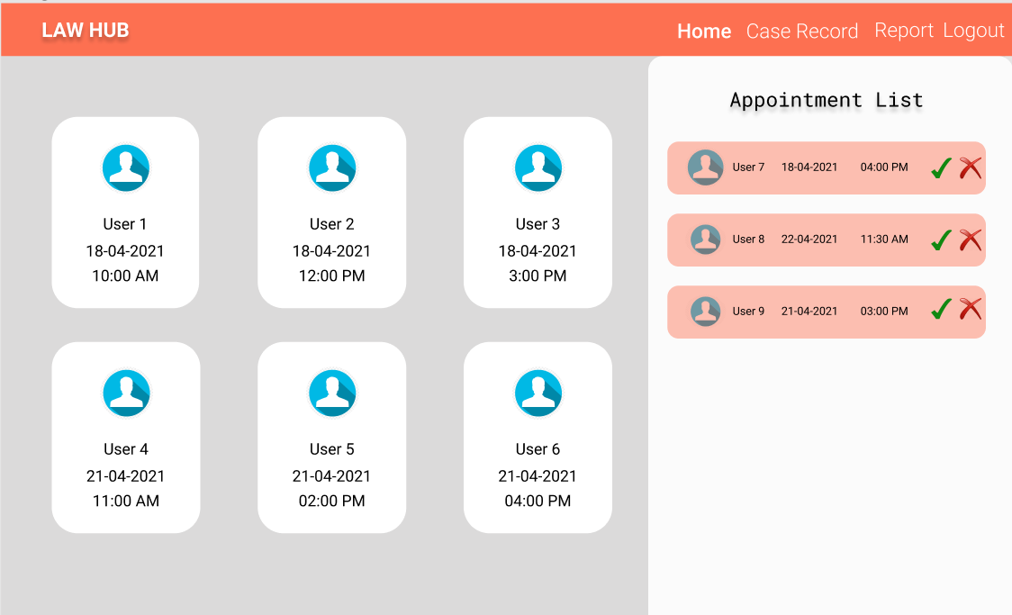
Case Record:
Output Screenshot:
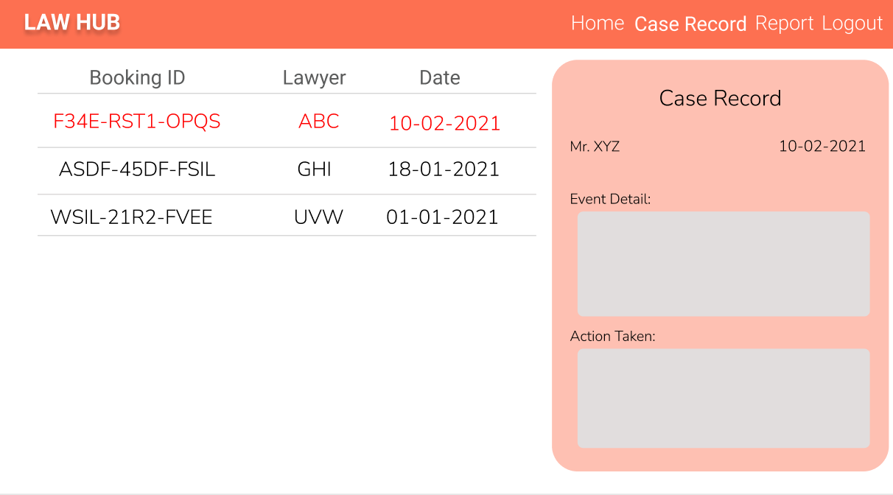

Report:
Output Screenshot:
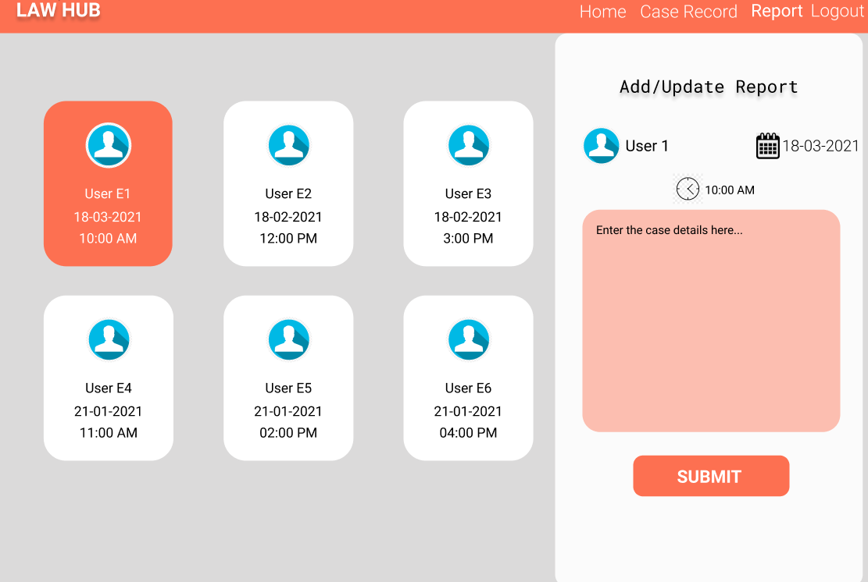

ADMIN:
Home:
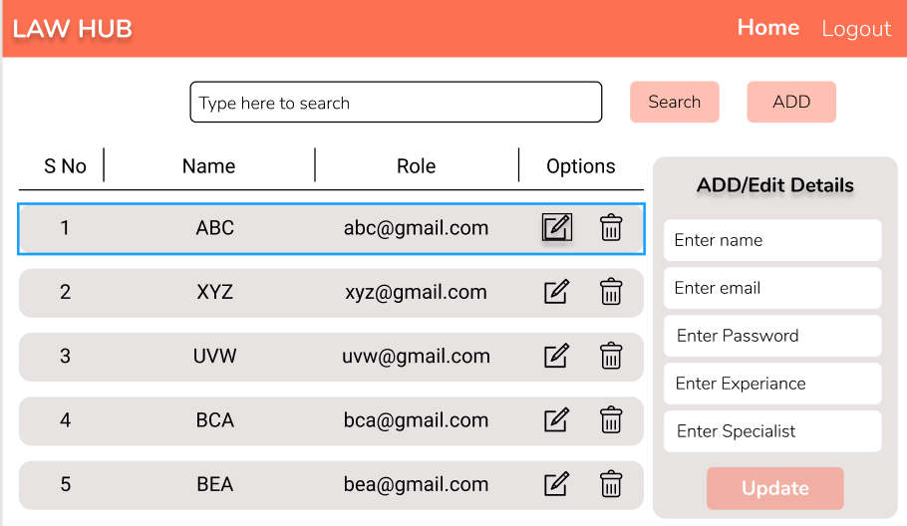
Backend:
Class and Method description:

Model Layer:

- UserModel: This class stores the user type (admin or the customer) and all user information.
  - Attributes:
    - email: String
    - password: String
    - username: String
    - mobileNumber: String
    - active: Boolean
    - role: String
  - Methods: -
- LoginModel: This class contains the email and password of the user.
  - Attributes:
    - email: String
    - password: String
  - Methods: -
- BookingModel: This class stores the appointment details.
  - Attributes:
    - bookingId: String
    - clientDetail: UserModel
    - LawyerDetail: LawyerModel
    - lawfirmName: String
    - date: Date
    - time: Date
    - bookingStatus: Boolean
  - Methods: -
- CaseRecordModel: This class stores the Case Record details for the users.
  - Attributes:
    - Case RecordID: String
    - userId: UserModel
    - date: Date
    - eventDetail : String
    - actionTaken: String
    - issuedBy: UserModel
  - Methods: -
- ReportModel: This class stores the.
  - Attributes:
    - reportId: String
    - appointmentDetail: BookingModel
    - Case RecordDetail: CaseRecordModel
    - date: Date
    - report: String
    - issuedBy: UserModel
  - Methods: -
Controller Layer:
- SignupController: This class control the user signup
  - Attributes: -
  - Methods:
    - saveUser(UserModel user): This method helps to store users in the database and return true or false based on the database transaction.
- LoginController: This class controls the user login.
  - Attributes: -
  - Methods:
    - checkUser(LoginModel data): This method helps the user to sign up for the application and must return true or false
- BookingController: This class controls the adding, upding, removing the booking details.
  - Attributes: -
  - Methods:
    - List<BookingModel> getBooking(): This method helps the admin to fetch all Booking from the database.
    - List< BookingModel > getBookingByLawyer(): This method helps the Lawyer to retrieve their all the booking from the database.
    - BookingModel bookingById(String id): This method helps to retrieve a booking from the database based on the bookingId.
    - statusModifier(BookingModel data): This method helps the Lawyer to edit a booking and save the status as Aprrove or Reject.
    - addBooking(BookingModel data): This method helps the client to add a new booking to the database.
    - removeBooking(String id): This method helps the Lawyer to delete a booking from the database.
- CaseRecordController: This class helps in adding the Case Record, deleting the Case Record from the cart, updating the Case Record.
  - Attributes: -
  - Methods:
    - addCase Record(Case RecordModel data): This method helps the Lawyer to add the Case Record to the user.
    - updateCase Record(Case RecordModel data): This method helps to update the Case Record.
    - deleteCase Record(String id): This method helps the Lawyer to delete a Case Record from the user.
    - viewCase Record(String id): This method helps the Lawyer to view the Case Record.
- ReportController: This class helps with the Lawyer to create/read/update the report details about the Clients.
  - Attributes: -
  - Methods:
    - List<ReportModel> getReportDetails(String id): This method helps to list the details based on the userI id.
    - addReport(ReportModel data): This method helps to save the report details in the database.
    - updateReport(CheckupModel data): This method helps to update the report details and store it in the database.

